**Installing the Force.com Migration Tool**

Before you install the Force.com Migration Tool you will need Java and Ant installed on your local machine. Then you can download the Force.com Migration Tool from a Salesforce organization.

Before you can use the Force.com Migration Tool, Java and Ant must be installed and configured correctly. You don’t need to install Java and Ant if you already have them on your computer, so first verify the installation from a command prompt.

## **Java**

Java version 1.7.x or later is recommended for better security and for the latest TLS security protocols.

To check the version of Java that’s installed on your system:

1. Open a command prompt.
2. At the prompt, type java -version and press Enter.

The output looks something like the following if you have Java version 7.

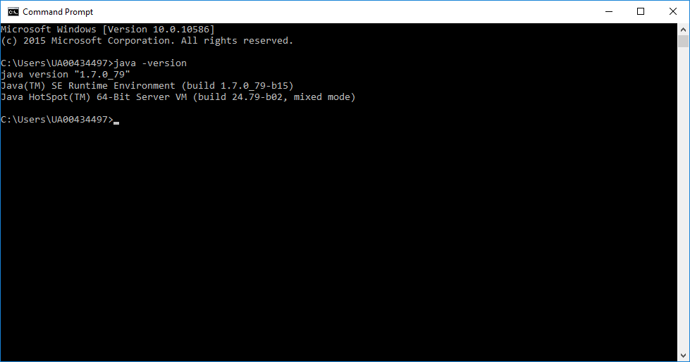

To install Java, go to <http://www.oracle.com/technetwork/java/javase/downloads/index.html> and get the latest version of the Java JDK. When you’re finished with the installation, verify by typing java -version at a command prompt.

## **Ant**

1. Open a command prompt.
2. At the prompt, type ant -version and press Enter.

The output should look something like the following:

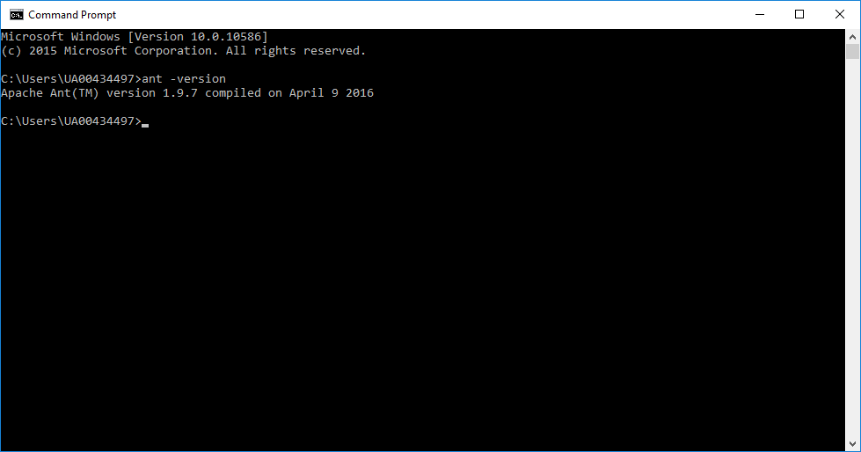

To install and configure Ant:

1. Download Apache Ant version 1.6 or later to a directory of your choice: <http://ant.apache.org/bindownload.cgi>. This directory known as ANT_HOME. When the files are on your computer, no further installation is required.
2. Add the bin directory to your path. (Only the bin and lib directories are required to run Ant.)
3. If you are using a Windows operation system, create an ANT_HOME environment variable and set the value to where you have installed Ant. Also create a JAVA_HOME environment variable and set the value to the location of your JDK.

# Install the Force.com Migration Tool

Follow these steps to download and install the Force.com Migration Tool.

1. Download the Force.com Migration Tool from the [Force.com Migration Tool](https://developer.salesforce.com/page/Force.com_Migration_Tool) page in [Salesforce Developers](https://developer.salesforce.com/).
2. Save the .zip file locally and extract the contents to the directory of your choice.

* If you installed a previous version of the Force.com Migration Tool and copied the ant-salesforce.jar file to the Ant lib directory, delete the jar file in the lib directory. The lib directory is located in the root folder of your Ant installation. The Force.com Migration Tool uses the ant-salesforce.jar file that’s in the distribution ZIP file. You don’t need to copy this file to the Ant lib directory. If you installed a previous version of the Force.com Migration Tool and copied the ant-salesforce.jar file to the Ant lib directory, delete the jar file in the lib directory. The lib directory is located in the root folder of your Ant installation. The Force.com Migration Tool uses the ant-salesforce.jar file that’s in the distribution ZIP file. You don’t need to copy this file to the Ant lib directory.

When you extract the Force.com Migration Tool ZIP files, the following folders and files are written to the location you specified:

* A Readme.html file that explains how to use the tools
* A Jar file containing the ant task: ant-salesforce.jar
* A sample folder containing:
  + A codepkg\classes folder that contains SampleDeployClass.cls and SampleFailingTestClass.cls
  + A codepkg\triggers folder that contains SampleAccountTrigger.trigger
  + A mypkg\objects folder that contains the custom objects used in the examples
  + A removecodepkg folder that contains XML files for removing the examples from your organization
  + A sample build.properties file that you must edit, specifying your credentials, in order to run the sample ant tasks in build.xml
  + A sample build.xml file, that exercises the deploy and retrieve API calls